**Activity 1 :**

A jet aircraft employs a system for monitoring the rpm, pressure and temperature values of its engines using sensors and operates as follows:

M sensor output=0 only when speed<4800 rpm

R sensor output =0 only when pressure <220 psi

T sensor output =0 only when temperature<220°F

Aim : Describe the logic circuit for condition that warning light should glow when the temperature is high AND pressure is high OR rpm is low/

Expression : W=T.(P+R’)

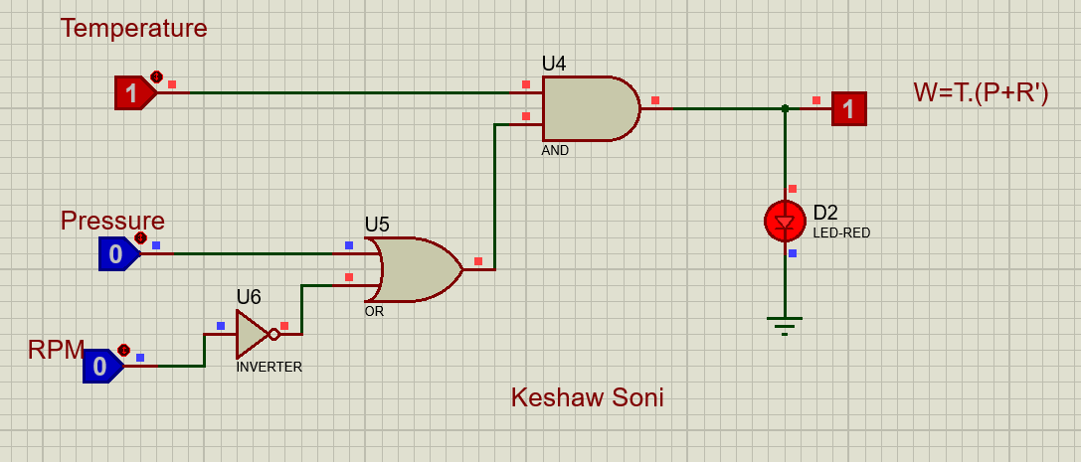

|  |  |  |  |
| --- | --- | --- | --- |
| **Temperature (T)** | **Pressure (P)** | **R.P.M. (R)** | **Warning Light** |
| 0 | 0 | 0 | 0 |
| 0 | 0 | 1 | 0 |
| 0 | 1 | 0 | 0 |
| 0 | 1 | 1 | 0 |
| 1 | 0 | 0 | 1 |
| 1 | 0 | 1 | 0 |
| 1 | 1 | 0 | 1 |
| 1 | 1 | 1 | 1 |

The light will glow when (T, P, R) = (1, 0, 0) , (1, 1, 0) , (1, 1, 1)